Deputy Director of Custom,

Sri Lanka Custom,

Dear sir,

**To explain the content in the package ordered via e commerce manufacturer over internet.**

The package I have imported contains STEM educational minicomputers for a program I’m currently involved with UNICEF Sri Lanka to educate children on Climate and weather.

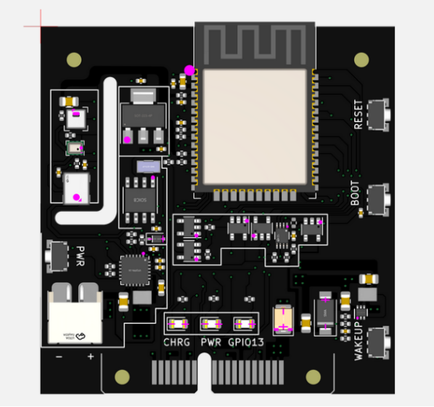

**Weather computer.**

Which is a programmable microcontroller device to measure air temperature, humidity, and air pressure to visualize and educational purposes.

This device false under the educational device as in HS article number **8479.89.10**

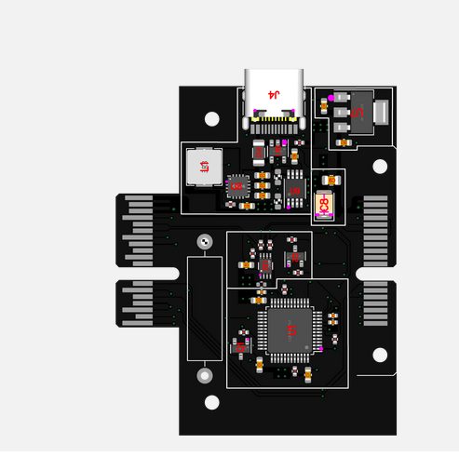**Programmable Solar Action Card (Comes with small adapter for Solar panel)**

Which is a programmable microcontroller device that comes with an internal power supply to measure solar energy.

This device false under the educational device as in HS article number **8479.89.10**

Best regards,

**DMGU Ushan Chaminda**

**Engineer, Educator**

Mobile Number: 0712587166

ID number :912090604V

Address : 15/8E, Samudra Devi Road Nugegoda.

